The scenic town of Mussoorie is popular as the‘ Queen of the Hills'. But it's not only a holiday retreat. It is also one of the most popular destinations to pursue education. Perhaps notably, Mussoorie's British-era schools are known throughout the world. And these schools also play a vital role in preserving this hill town's old-world charm
WOODSTOCK:
Founded in 1854, Woodstock School is located in the first range of the Indian Himalaya at an average altitude of around 7,000 ft. (2,100m). The campus lies within a protected forest area near the hill-station of Mussoorie. Woodstock aims to develop responsible global citizens and leaders by providing a world-class international education, rooted in its Christian heritage. Our diverse student body includes many from families serving India and the world. The school is affiliated to Cambridge.
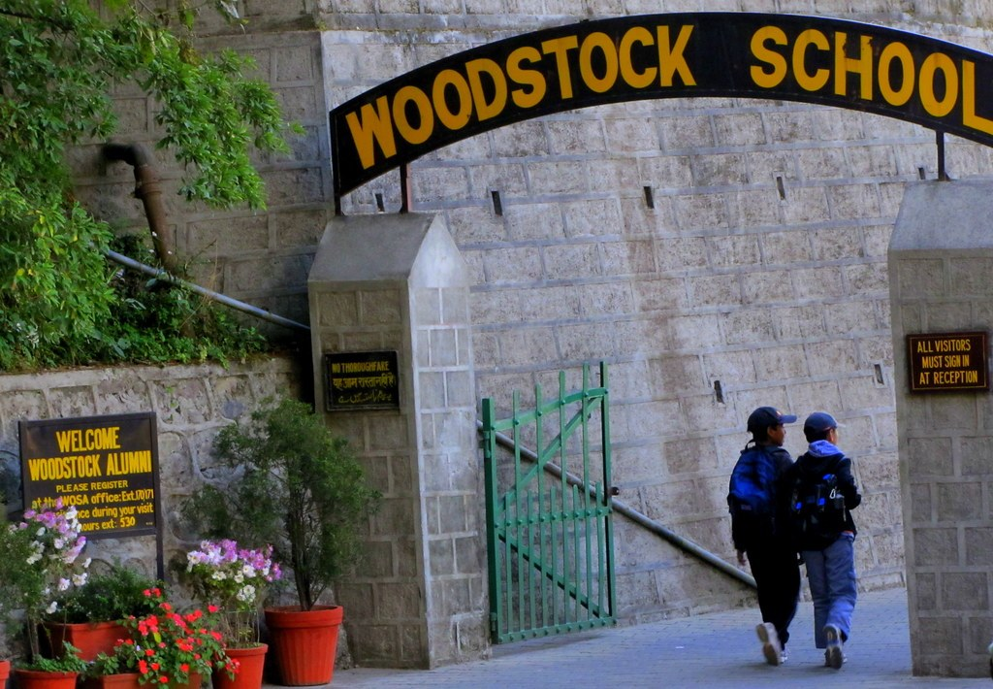

OAK GROVE SCHOOL:
It is a residential public School established in 1888. British East India Company started it on June 1, 1888. Oak Grove School is an English Medium Public Schools to the wards of railway employees at a highly affordable cost. The students are the children of the Indian Railways employees with only 25% of the seats reserved for outsiders. At present there are 560 students. School is affiliated by CBSE. The school aims at achieving the highest standard of excellence in academics, sports and co-curricular activities among students. Only 25% seats are offered to those who are not working in the railway system.

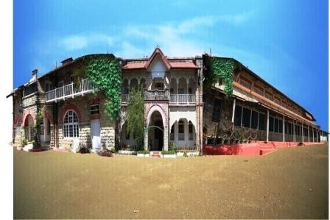

MUSSOORIE INTERNATIONAL SCHOOL
Mussoorie International School is a Girl’s Boarding School from class I to XII and is affiliated to CISCE. It was established in 1985. Students come here from as many as 27 countries from around the world and enrich their lives in an environment that provides all round development. The school offers a rich mix of the traditional and the modern the cultural heritage of the former, and the technological, pedagogical and creative advances of the latter. The institution has a learning environment that is refreshing and unfolds the true potential of every child. Here girls got excellent knowledge about academics, sports and co-curricular activities. The school also gives utmost importance to developing a strong foundation through discipline, character building and traditional values.

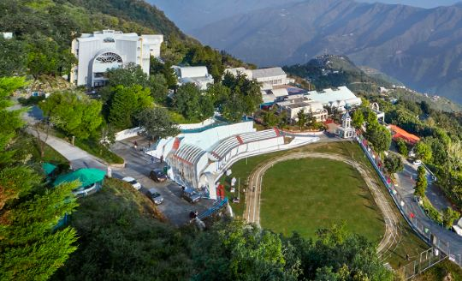

ST. GEORGE’S COLLEGE:
It is one of the premier boarding Schools in Mussoorie. Saint George College was established in 1853 by the Capuchin Fathers and entrusted to the Society of the Reverend Brothers of St. Patrick (Patrician Brothers of Ireland) in 1894. In 1948, St. Fidelis campus was amalgamated with St. George’s College. A pivotal resolve of the School is to shape leaders and statesmen and to actively contribute to the intellectual wealth and development of the nation. Debating, dramatics and music are encouraged in the School. Entertainment and instructional films are screened regularly. A number of leisure activities are offered.

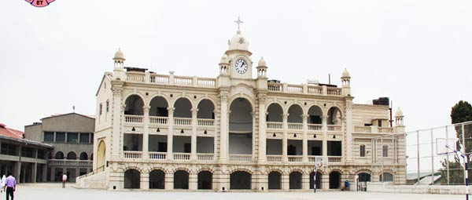

WYNBERG ALLEN SCHOOL
It was founded in 1888 by a group of friends, Mr. Alfred Powell, Mr. And Mrs. Arthur Foy and Brig. It is a residential co-educational institution, which accommodates around 700 children out of whom 550 are boarders. It is one of oldest educational institutions in India. It has always maintained an excellent standard of holistic education and co-curricular activities for its students. Their well-experienced team of teaching and non-teaching staff ensures that the young people entering the world turn out to be responsible citizens capable of steering themselves and their country towards excellence. The school is managed by The Wynberg Homes Society, a society registered under the Societies Act of 1860 and under the guidance of the Society the school has continued to flourish and progress and has firmly established itself as an educational institution that ranks among the finest in the country and which continues to develop and improve true to the school motto Excelsior.

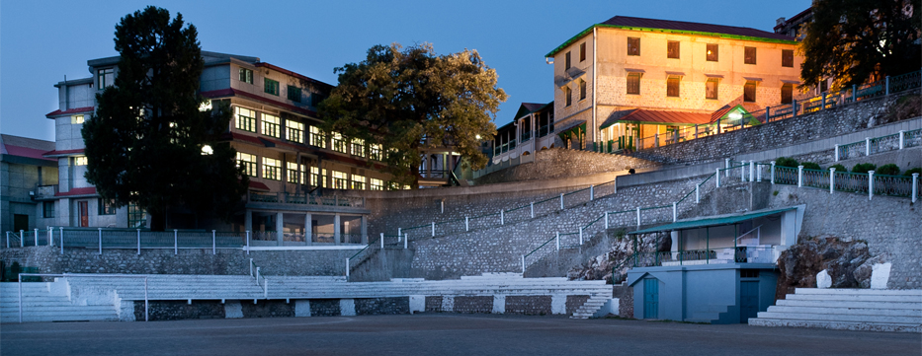

MUSSOORIE PUBLIC SCHOOL:
Mussoorie Public School is a well known English medium school in Mussorie. It is recognized by the Uttarakhand state government, Mussoorie Public School is a Co-Educational residential school established on 1966. It prepares students of Class X and Class XII for ICSE and ISC Examinations respectively. It was established in 1966 by founders Mrs Santosh Gaur, Mrs Gurucharan Kaur, Late Mrs Shashi Bala and Late Mrs Pushpa Puri. Now headed by Mr. Nirmal Gaur as Chairman, Mussoorie Public School prepares students for a next level of education. The students study various subjects including Sciences and languages. Modern methodology of teaching is followed as students are taught by using multimedia, audio-visual aids. It includes physical training as important as study and games like football, hockey, cricket, badminton, table tennis, volley-ball, basket ball, judo, karate, etc under the supervision of trained instructors.

